February 22, 2022

Ali MUHAMMAD

SY203155@Xaverian.ac.uk

nEA PROGRAM

HOTEL BOOKING SYSTEM

Contents

Analysis 2

Background to the identification of the problem 2

Current System 2

Identification of prospective users 2

Specific Requirements of the user and acceptable limitations 2

Data Dictionary for current system 2

E-R Model for existing system 2

Data Volume 2

Data Flow Diagram 2

Numbered objectives of the project 2

Proposed Method Of solution 2

Evidence of Analysis 2

Design 3

Overview of the system 3

E-R Diagram 3

Design Data dictionary 3

Description of Data Structures 3

Description of algorithms 3

User interface design 3

System security and integrity of data 3

Design making Criteria 3

Technical Solution 4

Testing 5

Evaluation 6

Evaluation against objectives 6

Overall Assessment of Project 6

User feedback 6

Analysis of user feedback 6

Possible extensions and improvements 6

# Analysis

## Background to the identification of the problem

For this project, I have decided to create a Hotel Booking system. I have chosen this problem due to certain small businesses who still use books to put down customers data which can be unsafe as the book is easily able to be misplaced. Also, it is very difficult to find the statistical data on how well the business is going whether it be daily/monthly/yearly gross income accumulated by the hotel reservations. Using an online booking system can solve these issues of lost data and statistical data. All the information on each customer will be safely stored in a secure database which will all be removed once the customer has ended their reservation.

The booking system will provide a wide range of rooms which the user will select based on the criteria that they have inputted. There will be boxes which the user is able to input the desired data and a room will be priced accordingly to the criteria that has been met. This will require them to select room preferences such as: check in date, check out date, room size, guests, name etc.

Each booking will get a unique BookingID which is used as a primary key for our database. This will be able to distinguish each customer from one and other and will be able to be used to cancel bookings decided so by the user.

There will also be a login screen which is used by mangers and the owner of the hotel to be able to access the statistical data which will be hidden otherwise if logged into by a customer. This data will be able to calculate the profits of the hotel on a daily, monthly and yearly basis. It will also show the bookings which have been made recently and any bookings that have been cancelled.

I plan for this booking system to be easy to use and simple on the outside. It is best to have a clear exterior for the most efficient use by users with no possibilities of users accidently inputting incorrect data and being charged for something extra that they may not have wanted.

## 

## Current System

I have a family member which runs his own hotel, it is a small business and due to him being 62 years old he is stuck to traditional methods of book as it is much more familiar to him after doing this for over 30 years before there were online booking systems. I have researched into the books used by my uncle and how the traditional system can be improved for a much more efficient and effective use.

These are the books that have been in use for a very long-time taking reservations of hundreds of people and more to come. I believe this is a very ineffective way to handle your business transactions due to it being very difficult to find statistical data which are useful in being able to find averages of income. In my program there will be a section which only managers are able to access to find these very quickly and efficiently with no need of adding up totals or even a chance for errors to occur.

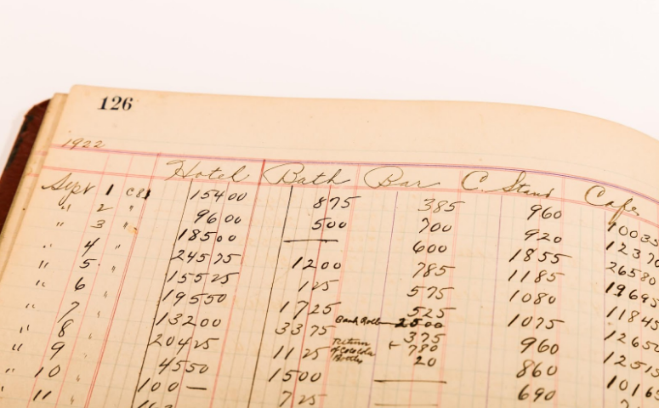In this picture you’re able to see the Date ins and Date outs which customers have chosen. As you can tell, it is very confusing to see which customer has checked in and when they are going to leave. This creates a problem where if you do not have enough experience with using these books it would be difficult to see when a room is occupied by a customer or when it is free. This system can be easily fixed by using a user input calendar where you are simply able to choose the date yourself firstly by selecting the Date in first then then Date out next.

This book shows a complete reservation for tens of customers however looking at it is just a bunch of numbers. This is not simple and is only able to be understood by workers who know their prices for my uncles’ hotel. Things such how large the room is, how many adults/children. The new system I will introduce will fix many of these problems by allowing a clear simple way of selecting these choices.

## Identification of prospective users

There will be a customer user and a manager user in this program. The customer user will have access to the booking/cancelling form used to create all their reservations and what is needed. The manager user will have access to both including the statistical data allowing them to see all the stats from databases and the income received for a time frame.

## Specific Requirements of the user and acceptable limitations

It is important that a large focus on the system will be about the booking aspect while other aspects that could be integrated such as reviews and ratings are not as high of priority due to time constraints however there still will be an attempt, if possible, to add to help make this system reliable. Another focus will be on the statistic data which are held in databases, this is very important for the management users as they’re able to see their data clearly and simply rather than what I have shown previously using old fashioned books.

In addition to the statistics form I aim to add many ways to be able to access different types of data such as daily/weekly/monthly/yearly and averages of each, however due to time constraints I may not be able to add a large amount of data into the MORE..

## Data Dictionary for current system

## (change to word format)

## E-R Model for existing system

Hotel

Booking

## x

Users

Room

## Data Volume

All of the data gathered from the user will be stored in databases, all the data stored will be the ones inputted by the user. The data will be

## Data Flow Diagram

## Numbered objectives of the project

1. When program is launched all the databases much launch with it

1.1. If database does not exist, then create the necessary databases.

2. Menu form should be open once program has started

2.1. Buttons on the menu should lead to different forms.

2.2 Booking/Cancelling and Statistics (if manager) should be on menu form.

2.3 Exit button to return to menu form should be available on all forms

3. On booking form, allow user to input the desired room type

3.1 Allow data such as, large room, 2 adults to be entered by user.

3.2. If no adults or children are selected display error message.

3.3. Making sure user is able to put in valid data such as correct DateIn and DateOut.

3.4. User personal data is able to be correctly inputted

3.5. if data is not valid allow an error message to show on screen allowing user to re-input data.

4. Allocate proper pricing depending on what is selected by user

4.1 If child is selected price will increase by x amount

4.2 If adult is selected price will increase by x amount

4.3 If small room is selected increase by x amount

4.4. if large room is selected increase by x amount

5. Allow user to book this room and enter the data into the database which will be saved onto it using SQL queries.

6. if all the data is correctly entered with no errors booking will be successful

7. Now the program will give the user a randomly generated BookingID

7.1 Show this ID on screen allowing for user to be able to remember or note down this id

8. ID will be used to be able to cancel an order or checkout once booking has ended.

9. Now in the cancelling/check out form it will ask the user to enter the BookingID given

9.1 Once inputted it will ask if it is a check out or cancel

10. To make sure this is the same person who had booked the room personal detailed will have to be inputted to make sure

10.1 if details are incorrect then cancelling/check out will not go through

10.2 if details are correct, all the data will be deleted

11. Now for the statistics form, when the button is clicked a login screen will appear over the form

12. User must have a manager login to enter and see stats

12.1 If login data is incorrect, it will ask to retry

12.2 if login data is correct, it will disappear showing the statistics form

13. Allow manager to click on a type of data they would like to see

13.1. CONTINUE WHEN STATISTICS FORM HAS BEEN MADE TO SEE WHICH DATA IS STORED

## Proposed Method Of solution

My solution to this problem will be made by using Visual studio C#. I will be using the forms to create a simple GUI that will allow users to simply and easily get their booking done fast. I will also be using SQL to create databases and store the necessary data on these which will be constantly updated for every user that inputs data. This is an effective way to tackle this solution as it is easy to manage and allows me to be in full control of what this program will look and feel like.

# Design

## Overview of the system

## E-R Diagram

## Design Data dictionary

|  |  |  |  |  |  |
| --- | --- | --- | --- | --- | --- |
| Field | Data Type | Length | Validation | ExampleData | Comment |
| Date In | Date | 8 | Cannot Be Null | 12/06/2021 | Entry Date |
| Date Out | Date | 8 | Cannot be Null | 14/06/2021 | Exit Date |
| Price | Int | 4 |  | £50 | Price of booking |
| Name | Var Char | 20 |  | John Smith | Name of user |
| Booking ID | int | 4 |  | 0712 | Unique Code to identify user |

|  |  |  |  |  |  |
| --- | --- | --- | --- | --- | --- |
| Field | Date Type | Length | Validation | ExampleData | Comment |
| Room Size | Int | 2 |  | Large | Size of room |
| Room Number | Int | 2 |  | 21 | Room user has booked |
| Price | Int | 4 |  | £50 | Price of booking |
|  |  |  |  |  |  |
|  |  |  |  |  |  |

## Description of Data Structures

## Description of algorithms

## User interface design

Exit: Closes program

Buttons which load the selected forms

This form is the menu which will be used as the main form. It will have all the other forms linking back to this and you will be able to return to this from the other forms using an exit button shown at the bottom right of each form, just like the one in this.

## System security and integrity of data

To be able to make this system secure and accurate it is important for all inputted data to be valid. This means that data that does not belong is certain areas of the database should not be able to be inputted such as numbers in the customers name box. This will allow for users to not make any mistakes as it is easy to incorrectly type the wrong data into a box which was meant for something else. To stop this from happening

## Design making Criteria

# Technical Solution

# Testing

# Evaluation

## Evaluation against objectives

## Overall Assessment of Project

## User feedback

## Analysis of user feedback

## Possible extensions and improvements